Mapping exercise: developing your escalation mapping pathway
Response processes need to be developed for each level of physiological abnormality that triggers escalation of care. This template has been adapted from a tool originally developed by the Australian Commission on Safety and Quality in Health Care. It offers a structured way to identify who will respond to each of level of physiological abnormality in your hospital. This will help you to develop your local escalation pathway. You may need to repeat the exercise for different clinical areas – for example, the mental unit may need to have a different escalation pathway from the acute surgical ward.
The New Zealand Early Warning Score (NZEWS) identifies multiple levels of worsening abnormality which trigger a graded response based on the seriousness of deterioration in a patient’s vital signs. Graded response systems may involve calling senior nurses and/or home team doctors for low or medium levels of abnormality, and a rapid response provider for high levels of abnormality. Response processes will vary depending on the local context of your hospital. A small rural hospital will have quite different processes from a large tertiary hospital.
All clinicians will need training and education in how to use your recognition and response system and in the essential clinical skills and capabilities needed to recognise and manage acute physiological deterioration. An eLearning module about using the national vital sign chart is available. There are a number of existing courses designed to teach essential clinical skills for managing deteriorating patients that may be useful to consider.
The following courses are examples, and are all freely available:
- The Acute Care Training (ACT) course, developed by and available from Waitemata DHB.
- The BASIC suite of courses including VeryBASIC and BASIC4NOW which were designed by a collaboration of Intensive Care clinicians to teach medical students, doctors and nurses.
https://www.aic.cuhk.edu.hk/web8/courses.htm
- The COMPASS education package, developed by and available from ACT Health in Australia.
http://www.health.act.gov.au/professionals/compass/compass-interactive-cd
You will also need to provide specific education and training for responders to ensure they have the clinical and non-technical skills needed to manage acute deterioration and understand their responsibilities in regard to communication and documentation. This is particularly important for tertiary responders who may not have critical care training (for example, for duty nurse managers who work as responders in small hospitals).
A fact sheet about capabilities for responders is available from the Commission’s website.
The escalation mapping exercise should be done for each level of physiological abnormality in your escalation protocol. Your escalation process should be developed with multidisciplinary input. You will also need to consider what related policy and guidance needs to be developed, reviewed, or updated to support the process (for example, guidance around clinical documentation, referral, handover and communication).
Figure 1 illustrates the overall escalation mapping process. Follow the steps in the template to help you to identify responses that are appropriate for your ward, department or facility. A worked example has been included at Appendix 1.
Figure 1: Escalation mapping process
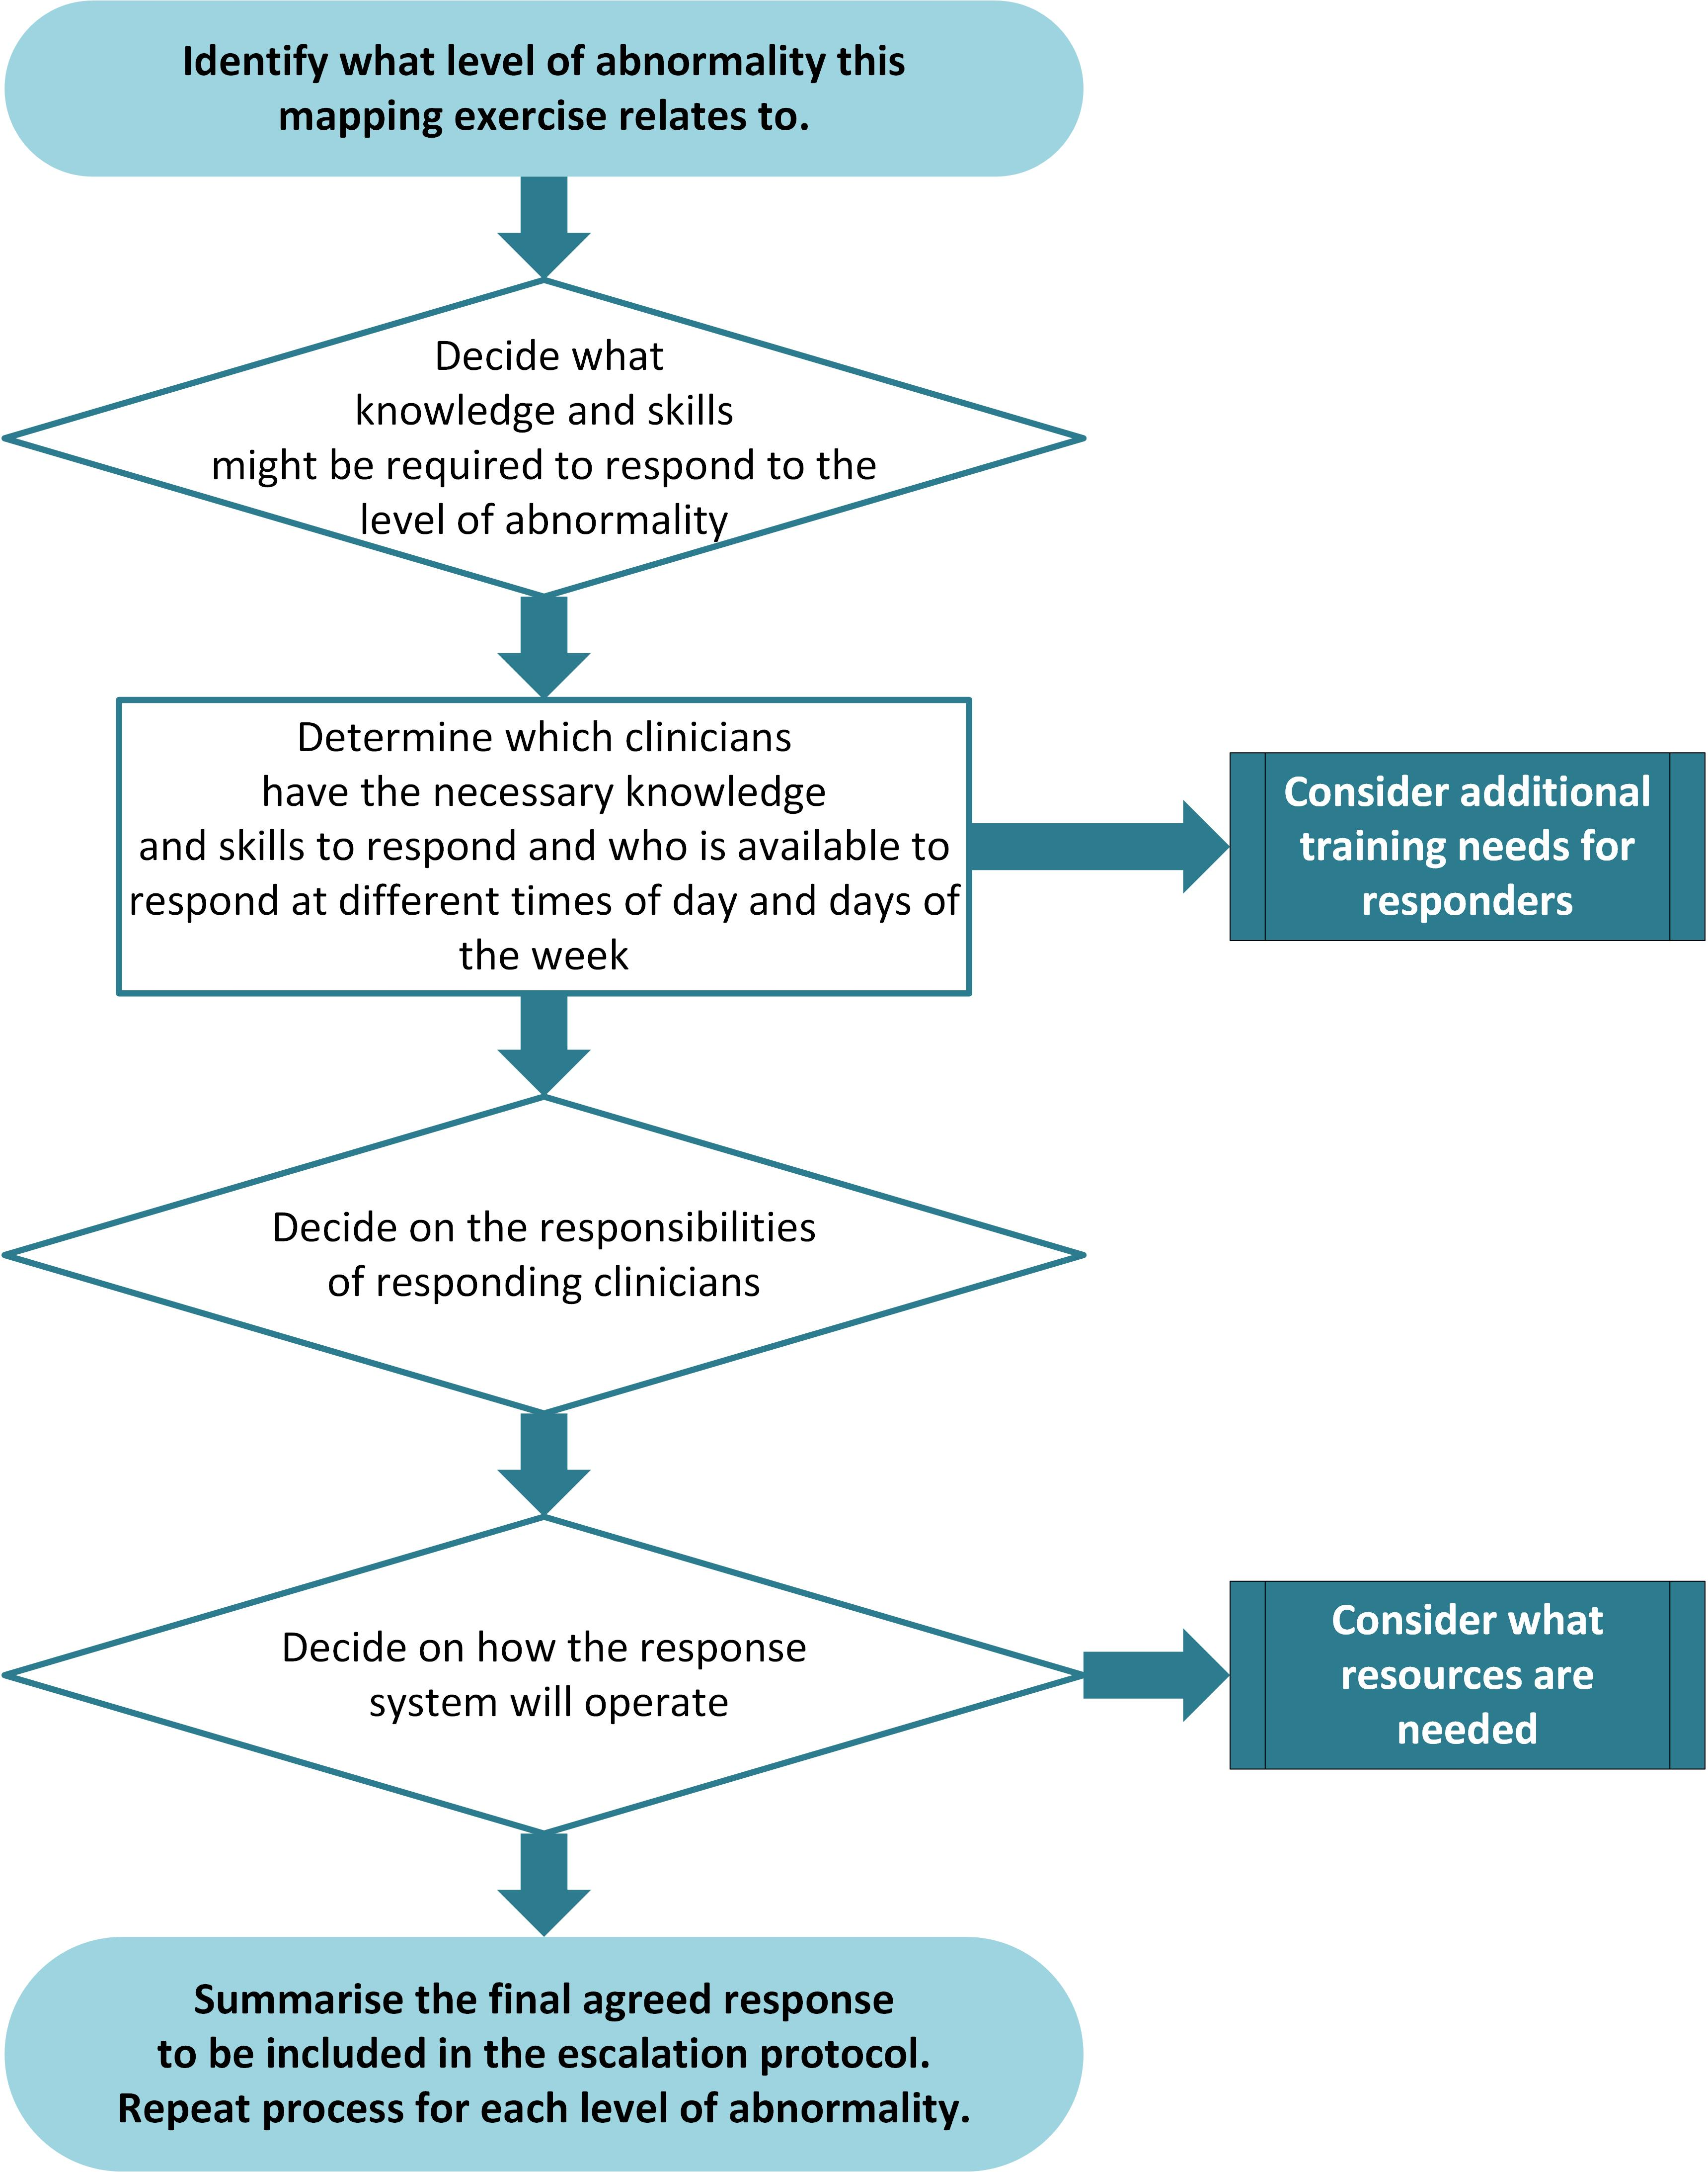

Level of physiological abnormality: Low | Total EWS: 1-5
List skills and knowledge that may / will be required to respond

List responding health professional(s) and number required |  | List the times these health professionals are available to respond
Responsibilities of attending health professionals:

What is the required timeframe for response given these levels of abnormality?

How will the health professional(s) be contacted?

Other than those attending the patient, who else should be notified?

What are the alternative or back up options for obtaining a response?

Is the necessary equipment available in the clinical area to undertake this treatment?
◻ Yes
◻ No → consider purchasing equipment or develop process for equipment to be brought to area
Final agreed response to be included in escalation protocol/policy and displayed on vital signs chart:

Level of physiological abnormality: Medium | Total EWS: 6-7
List skills and knowledge that may / will be required to respond

List responding health professional(s) and number required |  | List the times these health professionals are available to respond
Responsibilities of attending health professionals:

What is the required timeframe for response given these levels of abnormality?

How will the health professional(s) be contacted?

Other than those attending the patient, who else should be notified?

What are the alternative or back up options for obtaining a response?

Is the necessary equipment available in the clinical area to undertake this treatment?
◻ Yes
◻ No → consider purchasing equipment or develop process for equipment to be brought to area
Final agreed response to be included in escalation protocol/policy and displayed on vital signs chart:

Level of physiological abnormality: High
Total EWS 8-9 or single parameter trigger for red zone actions (listed below)
(NB if single parameter triggers total an EWS of 10+ a rapid response call is triggered)
Respiratory rate | 5-8 or 25-35 | Heart rate | 130s | Temperature | Not a trigger | Oxygen | Not a trigger
Oxygen saturation | ≤ 91% | Systolic blood pressure | 70s-80s or ≥ 220 | Level of consciousness | Responds only to voice or pain
List skills and knowledge that may / will be required to respond to each abnormality

List responding health professional(s) and number required |  |  |  | List the times these health professionals are available to respond
Responsibilities of attending health professionals:

What is the required timeframe for response given these levels of abnormality?

How will the health professional(s) be contacted?

Other than those attending the patient, who else should be notified?

What are the alternative or back up options for obtaining a response?

Is the necessary equipment available in the clinical area to undertake this treatment?
◻ Yes
◻ No → consider purchasing equipment or develop process for equipment to be brought to area
Final agreed response to be included in escalation protocol/policy and displayed on vital signs chart:

Level of physiological abnormality: Emergency/rapid response
Total EWS 10+ or single parameter trigger for blue zone actions (listed below)
Respiratory rate | <5 or >35 | Heart rate | 30s | Temperature | Not a trigger | Oxygen | Not a trigger
Oxygen saturation | Not a trigger | Systolic blood pressure | 50s-60s | Level of consciousness | Unresponsive
List skills and knowledge that may / will be required to respond to each abnormality

List responding health professional(s) and number required |  |  |  | List the times these health professionals are available to respond
Responsibilities of attending health professionals:

What is the required timeframe for response given these levels of abnormality?

How will the health professional(s) be contacted?

Other than those attending the patient, who else should be notified?

What are the alternative or back up options for obtaining a response?

Is the necessary equipment available in the clinical area to undertake this treatment?
◻ Yes
◻ No → consider purchasing equipment or develop process for equipment to be brought to area
Final agreed response to be included in escalation protocol/policy and displayed on vital signs chart:

Appendix 1: Worked example
The purpose of this worked example is to illustrate how to work through the process of planning appropriate responses to each level of physiological abnormality.
The content may not be relevant in every context as hospitals of different sizes will have different resources available.
Level of physiological abnormality: High
Total EWS 8-9 or single parameter trigger thresholds triggering red zone actions
(NB if single parameter triggers total an EWS of 10+ a rapid response call is triggered)
Respiratory rate | 5-8 or 25-35 | Heart rate | 130s | Temperature | Not a trigger | Oxygen | Not a trigger
Oxygen saturation | ≤ 91% | Systolic blood pressure | 70s-80s or >220 | Level of consciousness | Responds only to voice or pain | Or total EWS | 8-9
List skills and knowledge that may / will be required to respond to each abnormality
- basic airway management  - oxygen therapy  - auscultation of chest  - ABG and interpretation  - CXR and interpretation  - non-invasive ventilatory support  - ECG and interpretation, treatment of dysrhythmia |  |  |  | - systematic physical assessment  - IV access  - collection of pathology (UEC, FBC, blood cultures etc)  - prescription and administration of drugs and IV fluids  - ordering of CT/USS/other tests  - referral to other speciality  - communication with patient/whānau/carer and clinical team
List responding health professional(s) and number required  - Admitting team registrar  - RN caring for patient  - RN in charge of ward  - Outreach nurse |  |  |  | List the times these health professionals are available to respond  - Team registrar: Mon – Friday, 0800-1700hrs  - On call medical registrar: all other times  - Outreach nurse: 24/7  - Ward RN and nurse in charge: 24/7  - Alternative response: escalate to rapid response team
Responsibilities of attending health professionals:
Doctor, outreach nurse & RN caring for patient:
- undertake targeted physical assessment of patient
- provide urgent treatment (in consultation with admitting clinician)
- document plan for further treatment and review
- refer for further specialty input if required (e.g. cardiology/intensive care/radiology etc)
Nurse in charge:
- support RN caring for patient to undertake further assessments and treatments as required
- ensure other patients are attended to
What is the required timeframe for response given these levels of abnormality?
As soon as possible but within maximum 20 minutes, if caller considers a more urgent response is required they should call the rapid response team
How will the health professional(s) be contacted?
Registrar via mobile phone – advise patient name, location and admitting team
RN caring for patient and RN in charge – if unable to locate use assist call button
Other than those attending the patient, who else should be notified?
Registrar to contact admitting clinician once patient has been assessed
Nurse in charge of ward to be notified of patient deterioration
Patient and family updated
What are the alternative or back up options for obtaining a response?
Call rapid response team if patient deteriorates further or you are worried
Is the necessary equipment available in the clinical area to undertake this treatment?
◻ Yes
◻ No → consider purchasing equipment or develop process for equipment to be brought to area
Final agreed response to be included in escalation protocol/policy and displayed on vital signs chart:
- Registrar review within 20 minutes
- Notify RN in charge and outreach nurse
- Repeat observations in 15 minutes
- Call rapid response if patient deteriorates further or you are worried

